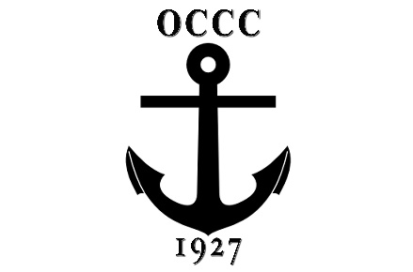
THANKSGIVING DINNER
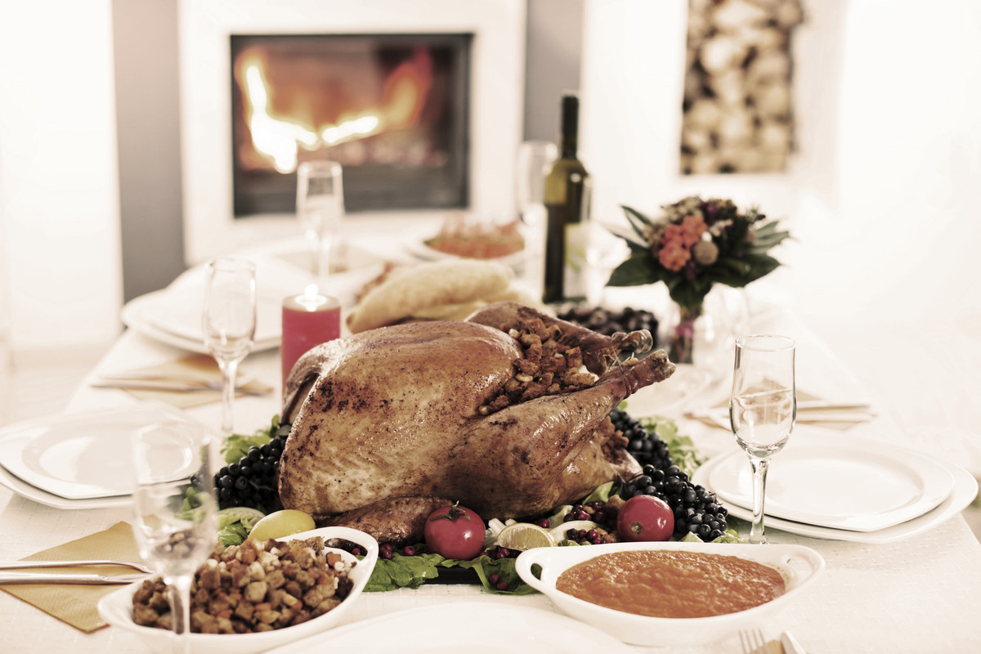
“TO-GO”
Are you entertaining family for the holiday and dread the cooking and cleaning?
Let Chef Jesse and the OCCC culinary team take care of Thanksgiving Dinner for you.
Thanksgiving “To-Go” packages include;
ROASTED WHOLE TURKEY, CORN BREAD STUFFING & GRAVY, AUGRATIN POTATOES, MACARONI & CHEESE, COUNTRY STYLE GREEN BEANS, CORN PUDDING, CRANBERRY SAUCE, YEAST ROLLS AND YOUR CHOICE OF PIE.
Package #1 feeds approximately 8-10 adults- $189
Package # 2 feeds approximately 18-20 adults- $289
Add Honey Baked Ham to your package; Half Ham= $45 Full Ham= $75
Please note: Package Pick-Up on Thanksgiving Morning will be @ 10:00 am.

THANKSGIVING “TO-GO” 2018
Complete and return to Business Office or via e-mail to LKraft@owlcreekcc.com
by Friday, November 19, 2018
Name______________________________________________________
Member #_______________
Phone #__________________________E-Mail Address_____________________________________

Package#______________Choice of Pie (circle one) Pumpkin or Pecan
Please Add a (circle one) Half Ham Full Ham
Special Instructions___________________________________________________

